Model for Collegiate Graduation Rates

Every year hundreds of thousands of students apply to colleges all over the country and globe looking to obtain a higher education in order to set up a long lasting, rewarding career. When considering which schools should top their application list, each potential student has different factors they consider and every student weighs these factors differently. Some may look for certain majors or programs while others filter the school by size. One factor that is almost always a determinate is graduation rate, that is the percentage of students that will successfully graduate from that school. Although these rates are always changing for every school it is general belief that some schools for whatever reason are more successful at graduating students than others. This analysis looks to find an effective model from predicting the graduation of an incoming freshman class at a given college.

Interpretations

We are 95% confident that when all other variables are average, colleges in the Midwest region are associated with a 5.193% higher mean graduation rate than colleges in the West for all US colleges between the years of 1994 and 1995.

We are 95% confident that when all other variables are average, colleges in the Northeast region are associated with a 8.597% higher mean graduation rate than colleges in the West for all US colleges between the years of 1994 and 1995.

We are 95% confident that when all other variables are average, colleges that receive private funding are associated with a 5.370% higher mean graduation rate than colleges that receive public funding for all US colleges between the years of 1994 and 1995.

After adjusting for all other variables, we are 95% confident that each increase in 1% of students from the top 10% of their high school class are associated with an increase of .169% in the mean graduation rate for all US colleges between the years of 1994 and 1995.

After adjusting for all other variables, we are 95% confident that each increase of one dollar in cost for room and board is associated with an increase of .00141% in the mean graduation rate for all US colleges between the years of 1994 and 1995.

After adjusting for all other variables, we are 95% confident that each increase of 1 percentage point in alumni who donate to the school is associated with an increase of .181% in the mean graduation rate for all US colleges between the years of 1994 and 1995.

After adjusting for all other variables, we are 95% confident that each increase of 1 percentage point in expenditure per student as a percentage of tuition is associated with a decrease of 8.123% in the mean graduation rate for all US colleges between the years of 1994 and 1995.

After adjusting for all other variables, we are 95% confident that each increase of 1 standard deviation in average SAT/ACT scores for the incoming class is associated with an increase of 4.988% in the mean graduation rate for all US colleges between the years of 1994 and 1995.

After adjusting for all other variables we are 95% confident that each increase of 1 percentage point in the percentage of applicants accepted by the school is associated with a decrease of 8.390% in the mean graduation rate for all US colleges between the years of 1994 and 1995.

Initial Model: nothing changed, regions included



**--note: only 683 observations used out of 937 rows (due to missing values)**

Effects leverage cut-off

**--new coded variable included in initial regression**

regions from US census regions; DC included in South region

**--high VIF**

FTUG, apps, enrolled, accepted

**--possible transformations**

Since we don’t have total school population, can’t transform FTUG in a meaningful way

Change accepted to accepted/apps

Change enrolled to enrolled/accepted

**--residuals**

Checking equal variance and linearity:

Spending has fan shape-->log transform

Note: enrolled, apps, accepted look strange, but we have intentions to change those variables to reduce multicollinearity

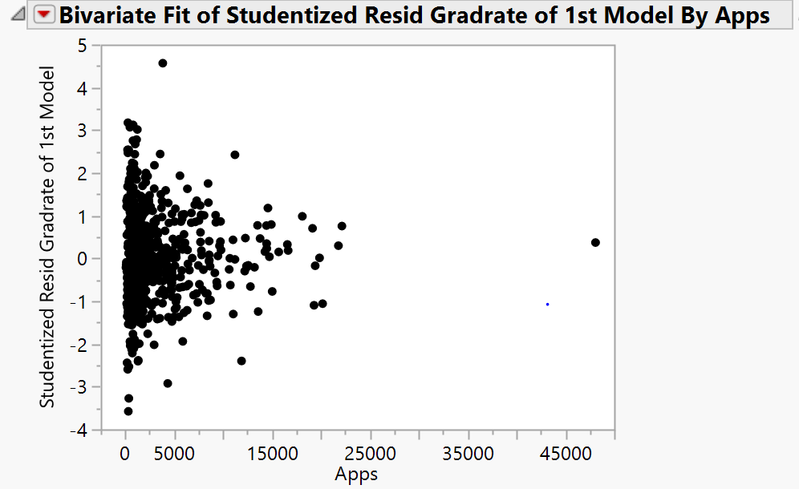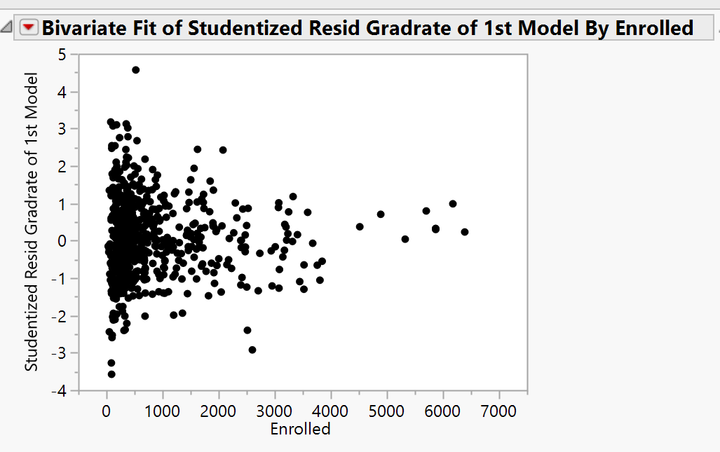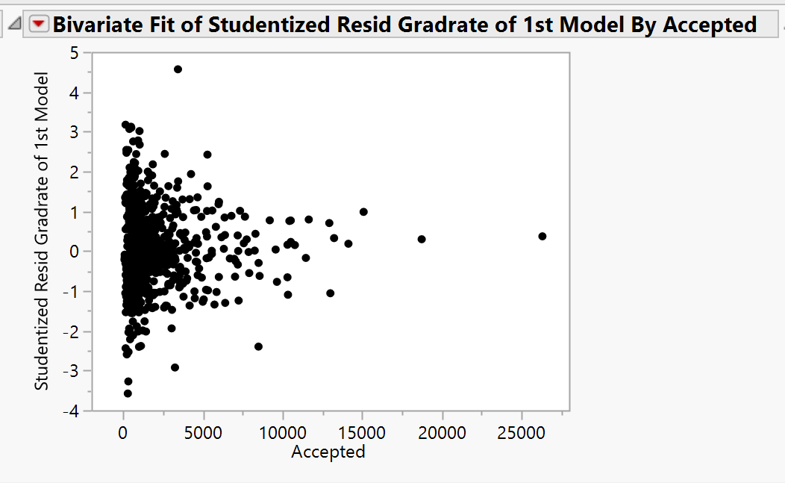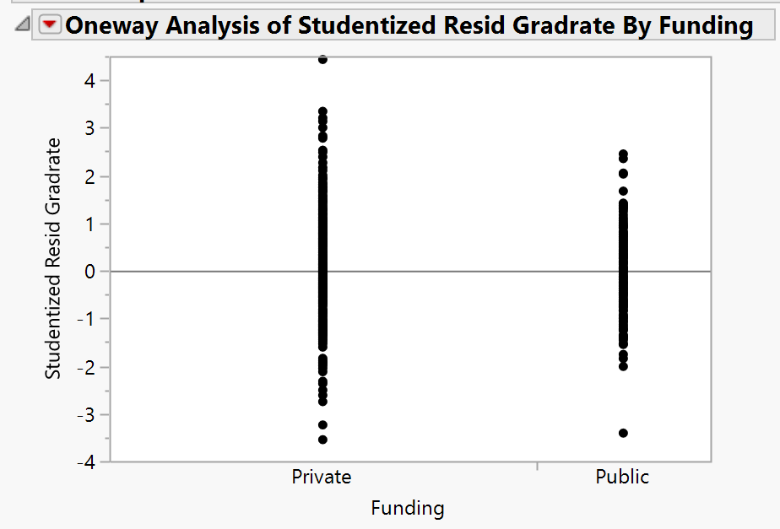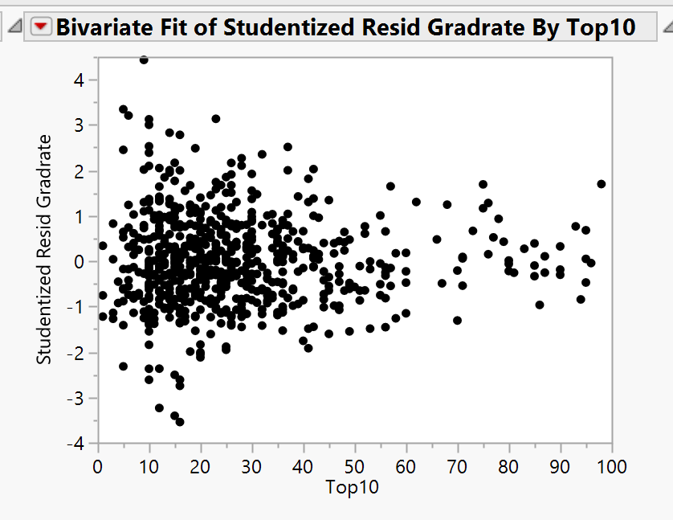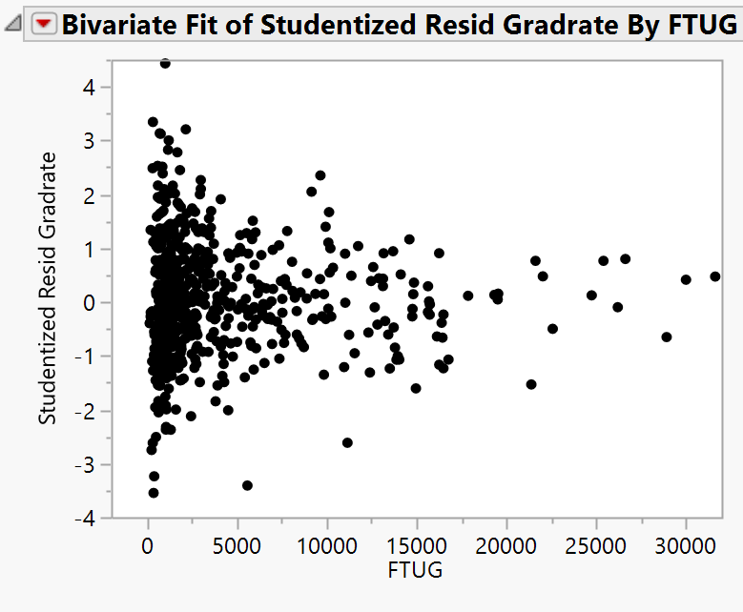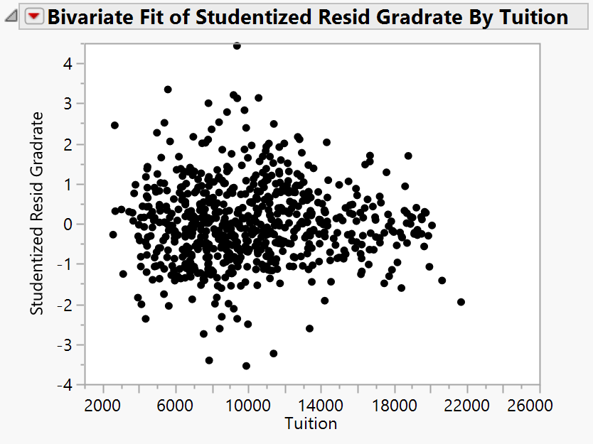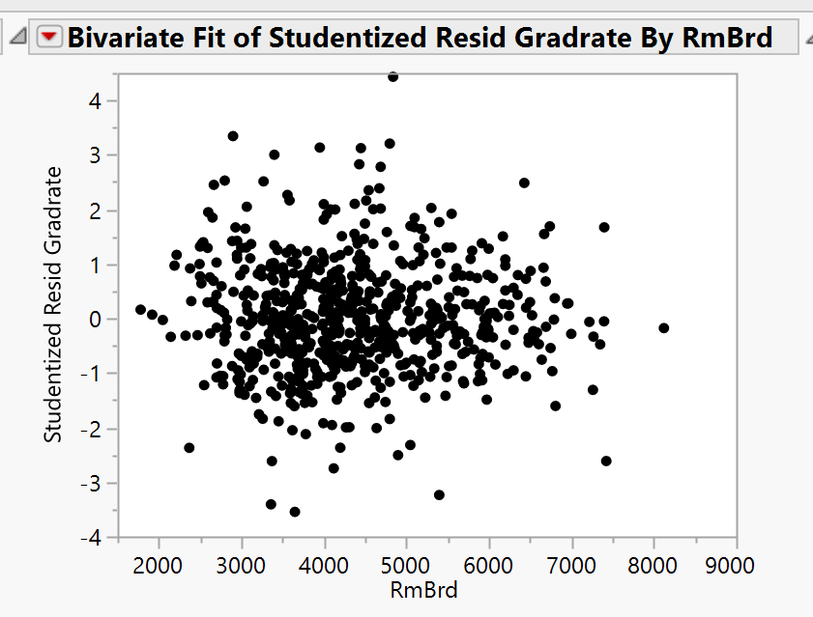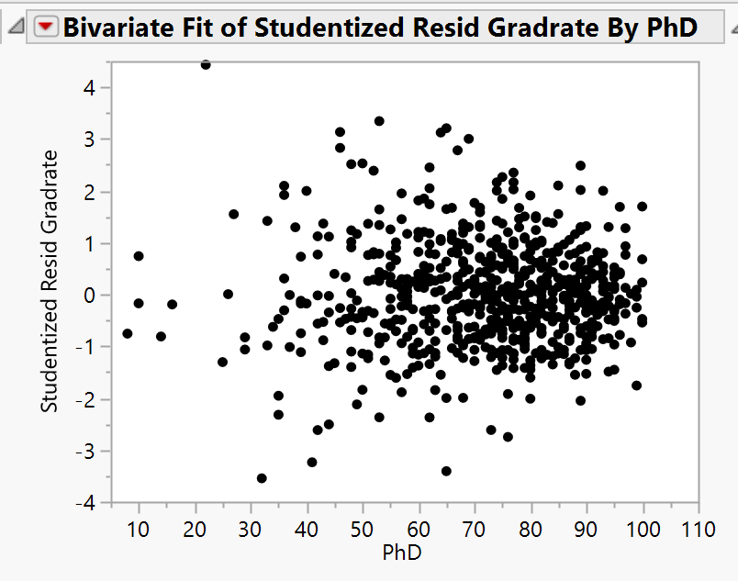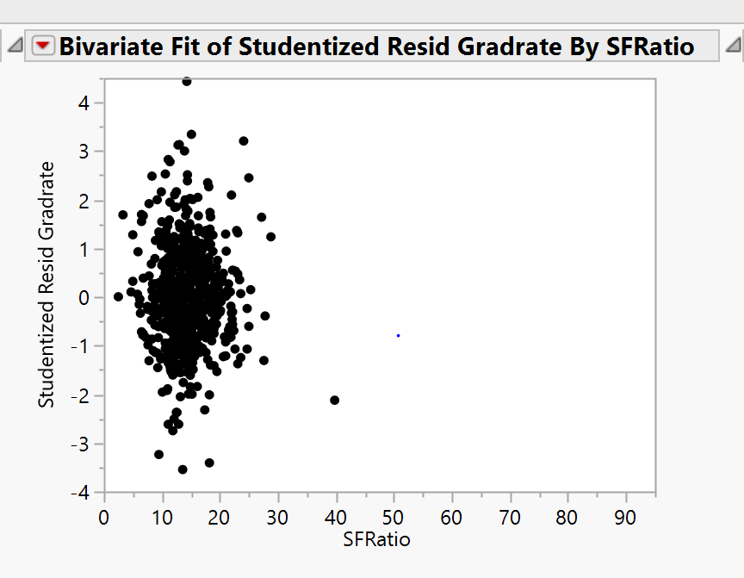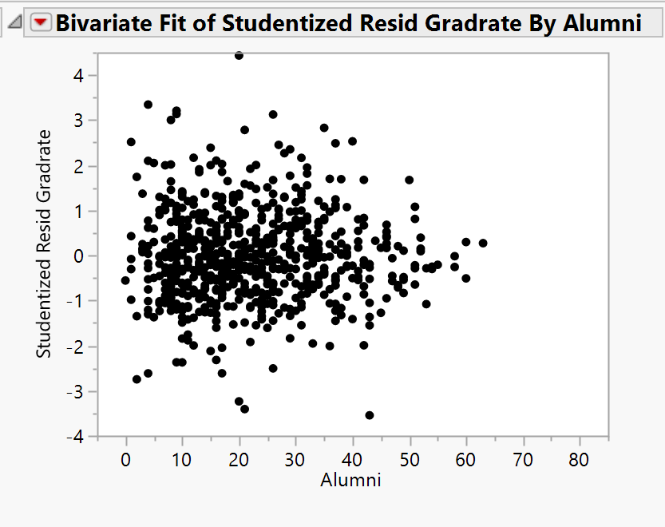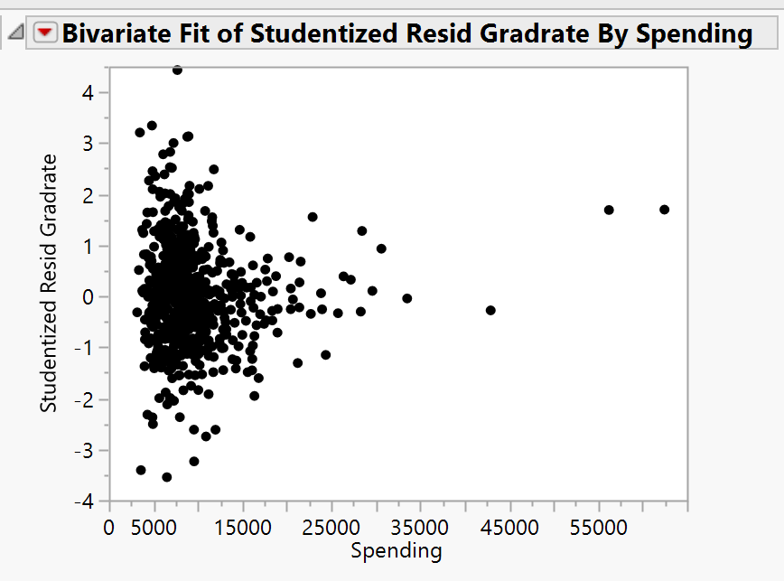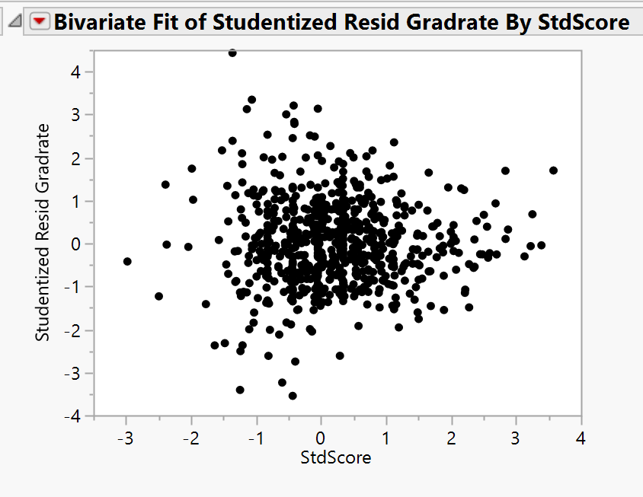

The spending variable showed unequal variance but once transformed using a log it seems to have both linearity and equal variance

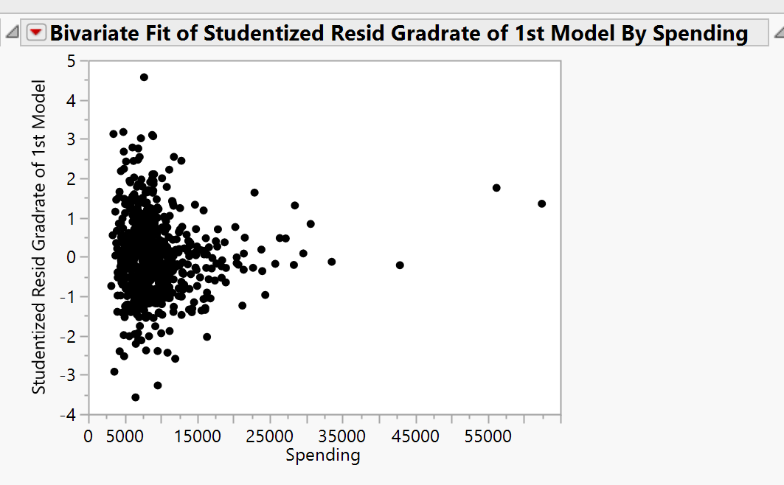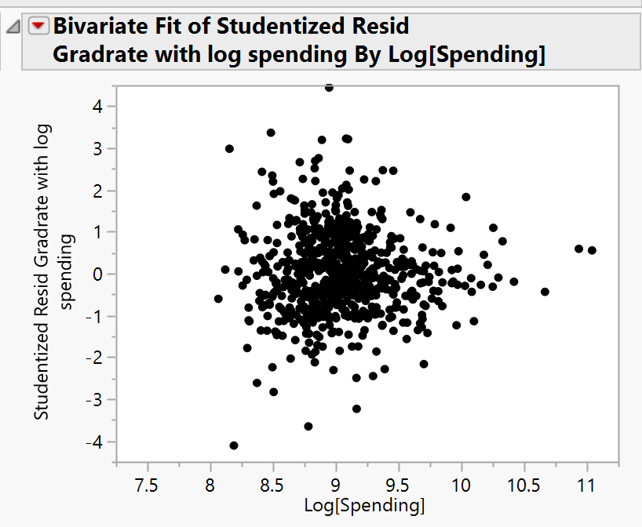

Checking normality: assumption appears to be satisfied, but there are clearly outliers

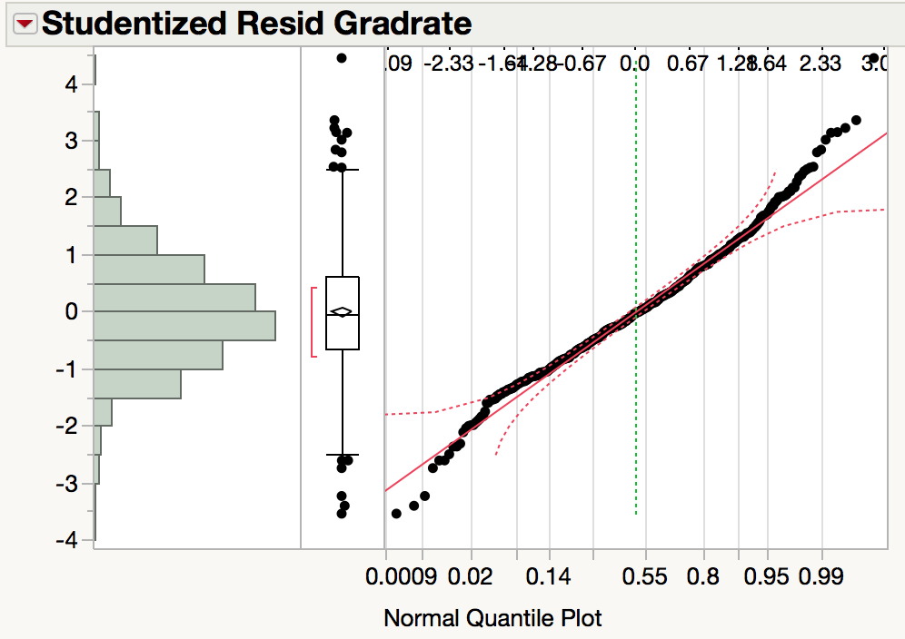

**Checking outliers:**

Data point 551 (Cazenovia College) has a grad rate of 118%

Decision: delete from regression because it is impossible

9 extreme outliers: cutoff = 3SDs above/below 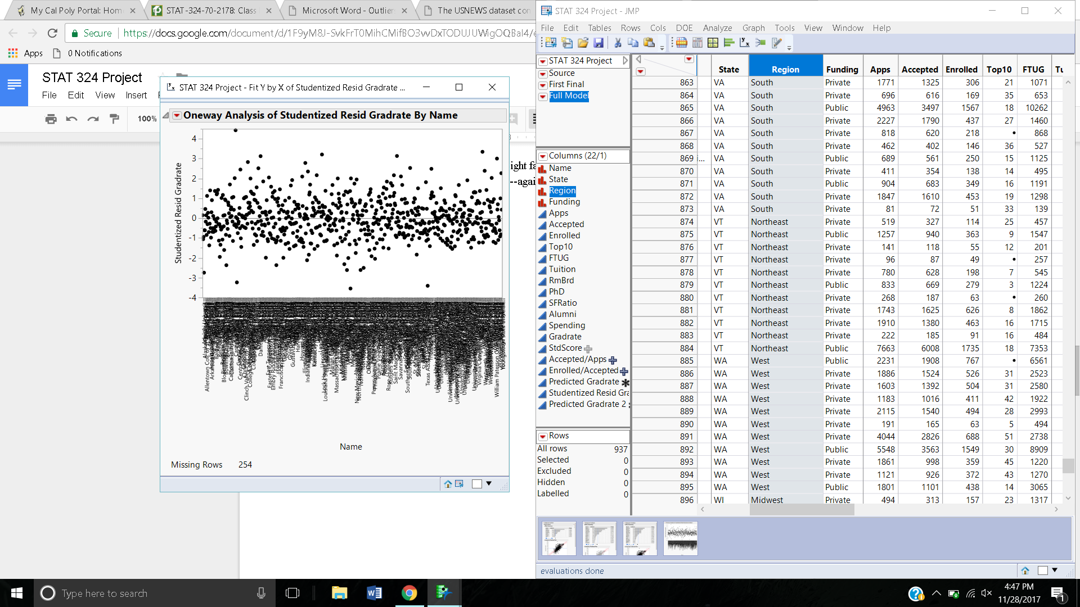

High: Cazenovia College

Davis and Elkins College

Lindenwood College

Salem-Teikyo University

Webber College

Wingate College

Low: Centenary College

Mount Saint Clare College

Texas Southern University

No outliers were data entry errors besides the cazenovia college

**Checking leverage:** cutoff =0.0703

Antioch University

Brown University

California Institute of Technology

Center for Creative Studies

Duke University

Indiana State University

Indiana Wesleyan University

Jamestown College

Johns Hopkins University

Michigan State University

Pennsylvania State University

Princeton University

Purdue University

Rutgers at New Brunswick

Texas A&M University

Texas Southern University

University of California at Irvine

University of California at Riverside

University of California at San Diego

University of California at Los Angeles

University of California at Berkeley

University of California at Santa Cruz

University of California at Santa Barbara

University of Illinois

University of North Carolina

University of Texas at Austin

**Checking influence:**

Cook’s Distance cutoff: 50th percentile of F distribution with 16, 667 df : 0.9596

No Cook’s distances were larger than the cut-off

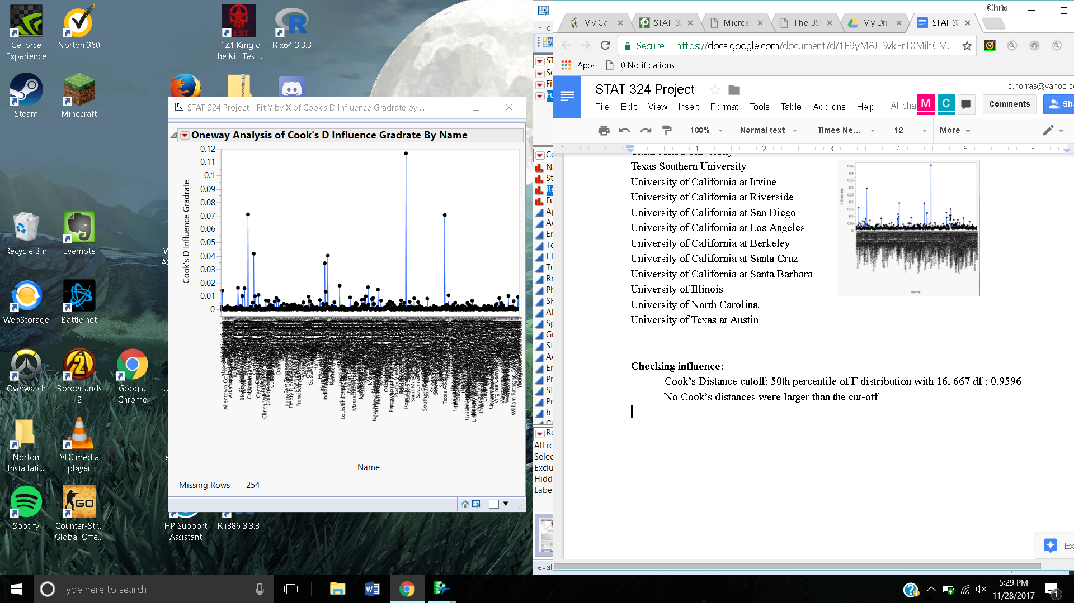

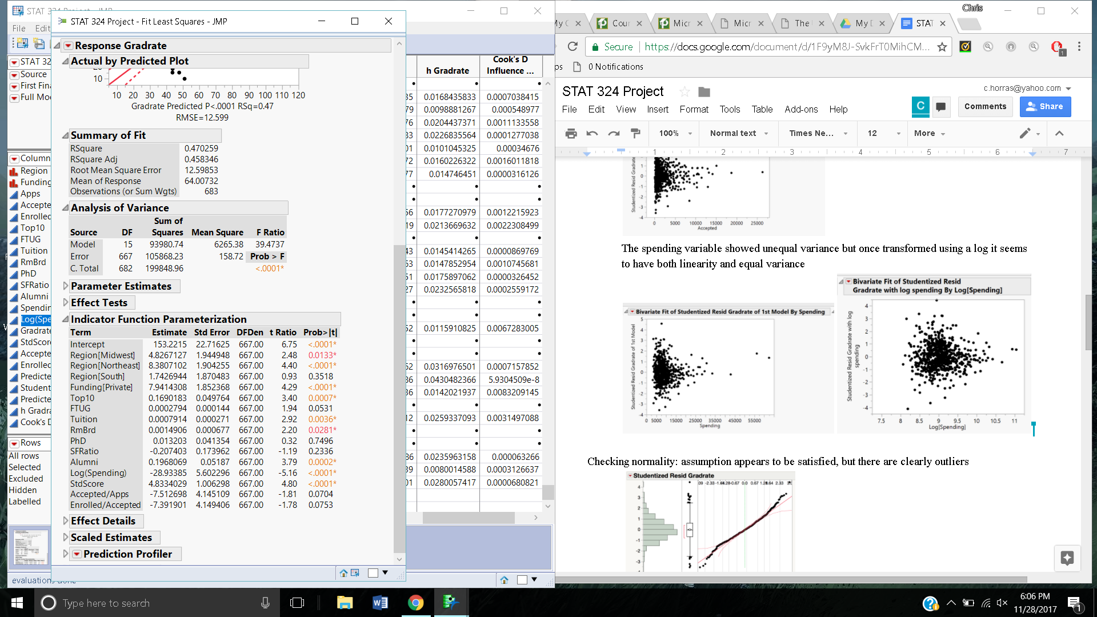

Next Steps

Transform variables

Figure out what to do with outliers, high leverage

Run best subsets

Pick best model

Final Steps

Add interactions

Run best subsets

Pick best model

Check Assumptions

Regression with log(spending) and enrolled, accepted, and apps divided through



Interactions: Alumni*Funding, Tuition*Funding, Log(Spending)*Funding, Top10*apps, Spending/tuition*funding, PhD*SF ratio

Tried and none were significant

New VIF/MC issue with model that has log(spending) and the divisions

**Proposed:** Try Spending/Tuition

-No violations

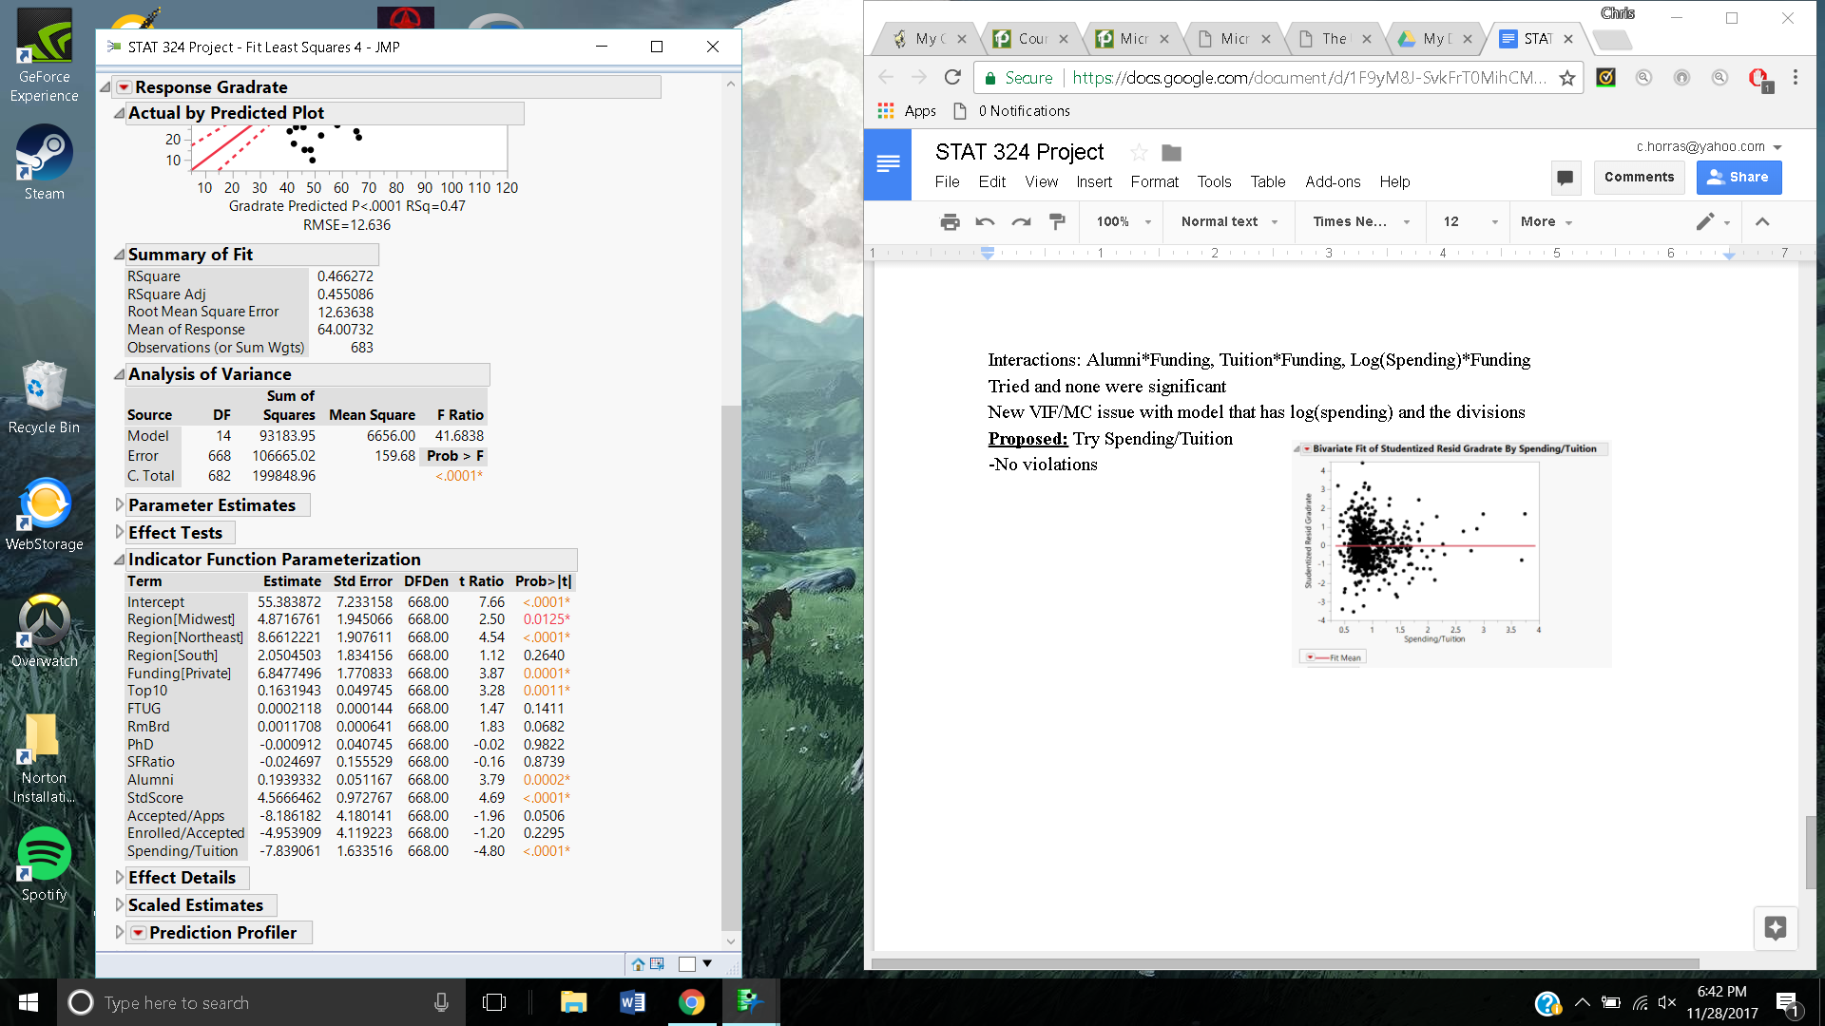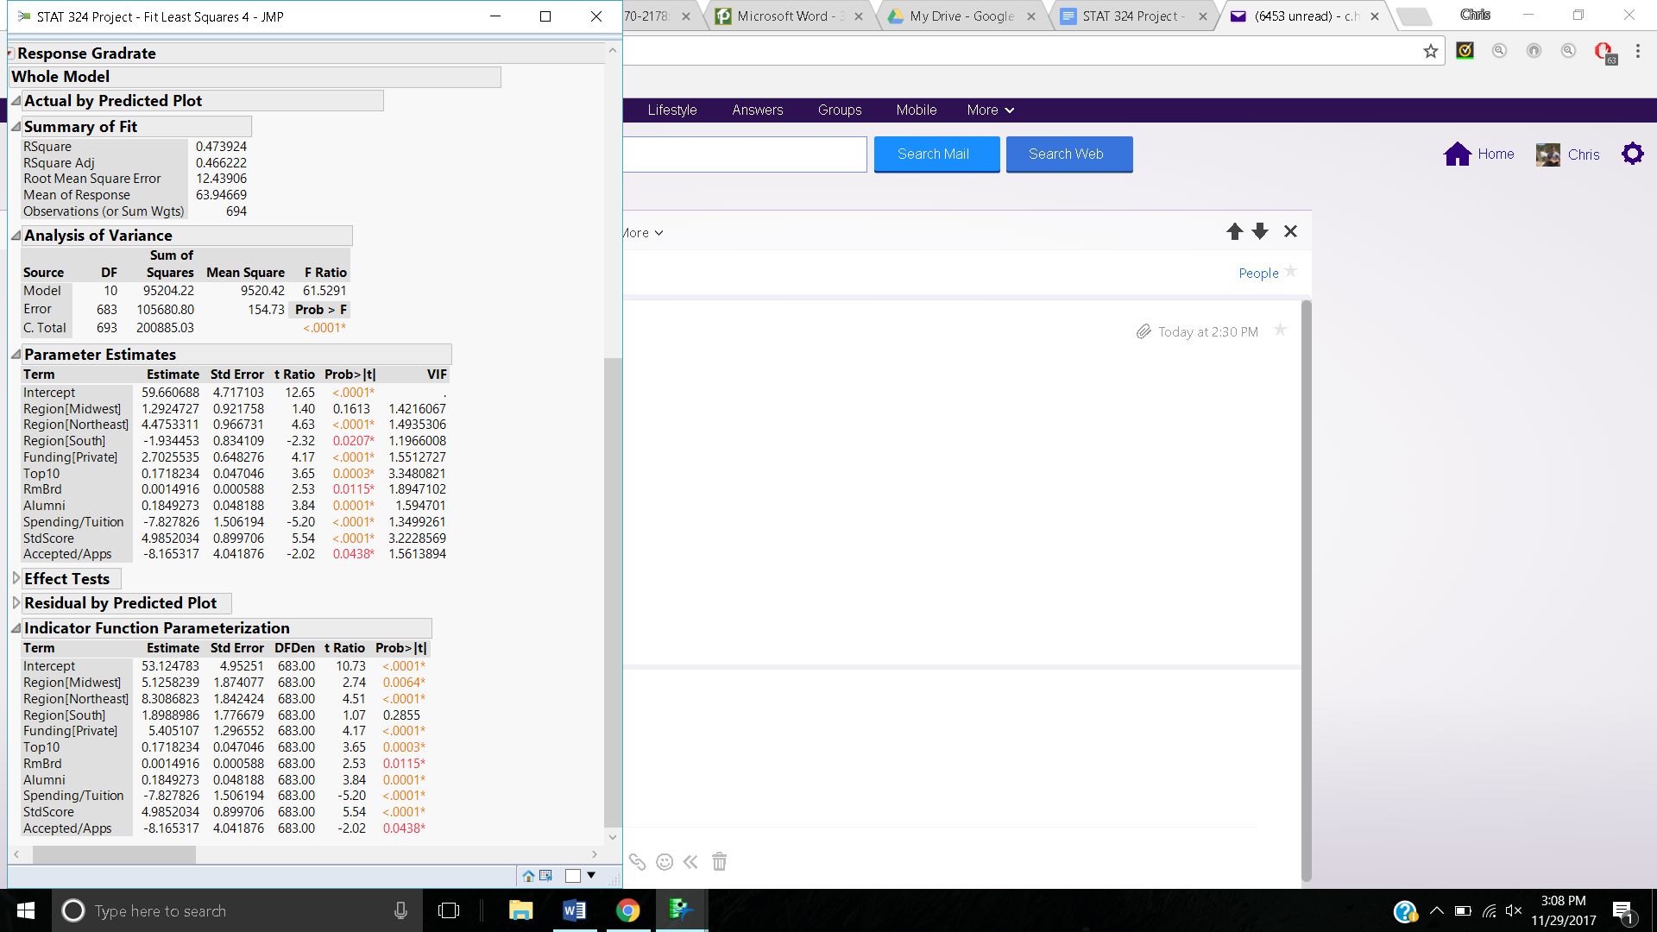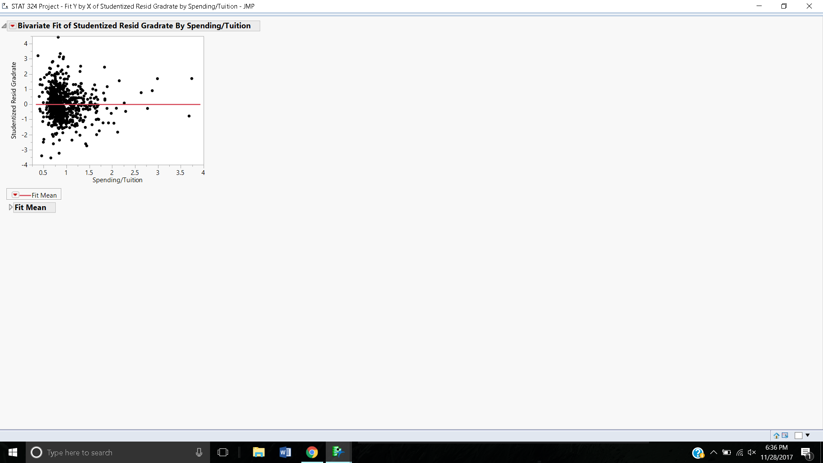

-Before doing best subsets we should decide if we want Log(spending) or Spending/Tuition

**-Final Model**

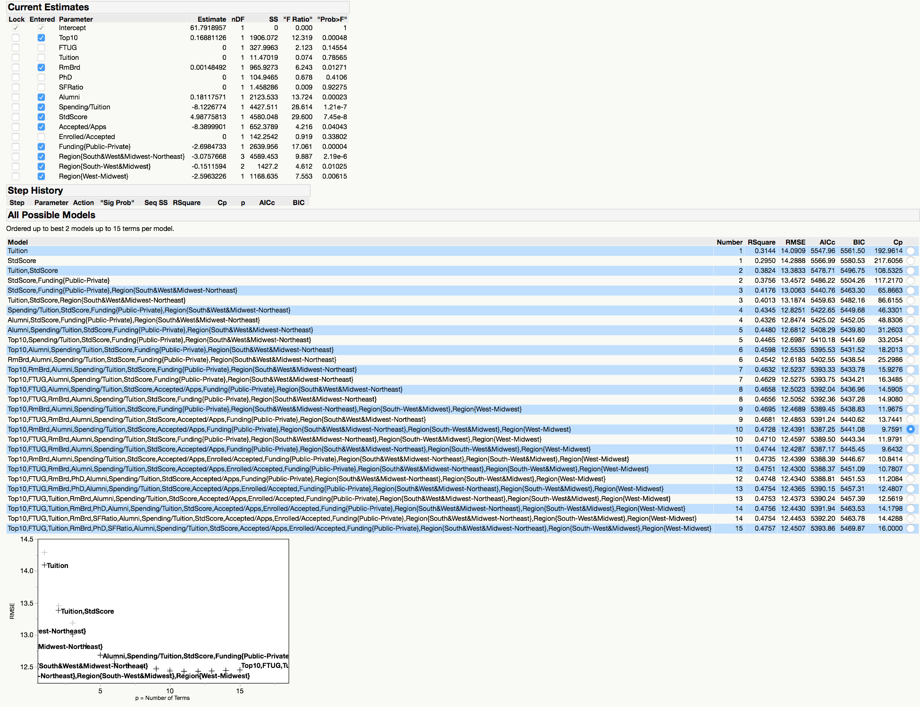

Significant interactions: Accepted/apps * funding, not using because p-value was just above .05 and makes main effect insignificant → very small rsq adj improvement so we choose to not include it in final model

top10*std score=.08

accepted/apps*std score=.04

accepted/apps*tution= not significant

Checking assumptions:

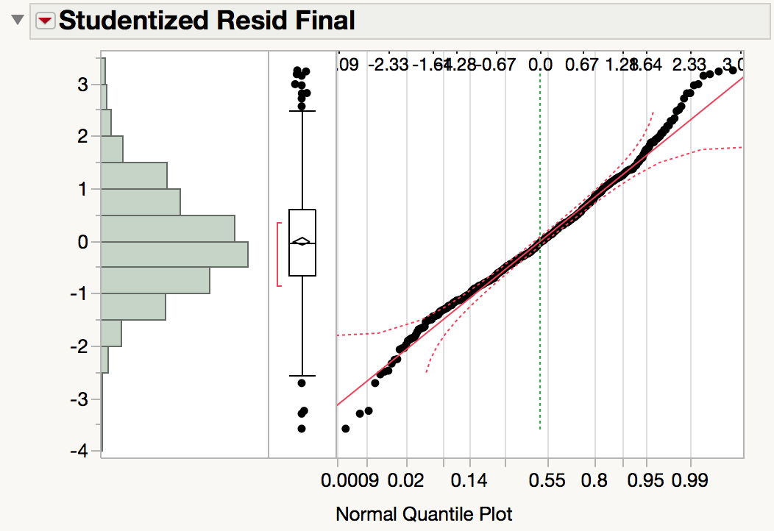

Normality assumption is ok

Leverages: cutoff: 11*3/694= .04755

--note: more observations now because some colleges were just missing data for one variable (like SF ratio) and now some variables are not included in regression

Outliers: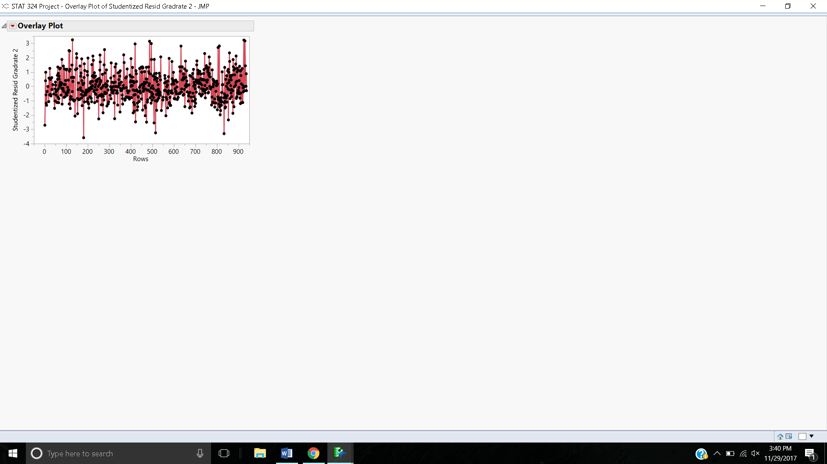

+3SDs above: Davis and Elkins college

Salem Teikyo College

Webber College

Wingate College

-3SDs below: Centenary College

Mount Saint Clare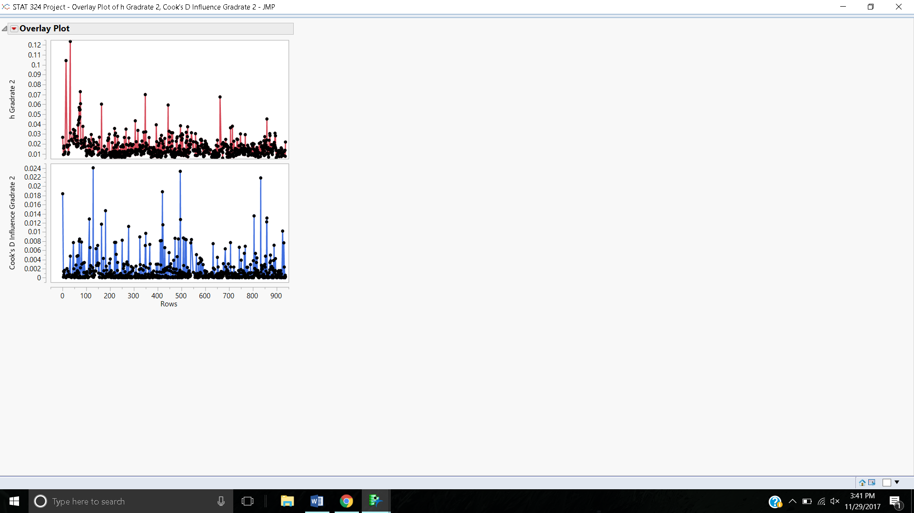

Texas Southern University

Leverages:

Antioch University

California Institute of Technology

John’s Hopkins University

Rust College

UCLA

UCSD

UCD

UC Santa Cruz

University of Hawaii at Manoa

UCSB

University of Alabama

Influential Observations: cut-off = 0.941

Nothing even close (all below .03)

Keep Tuition in

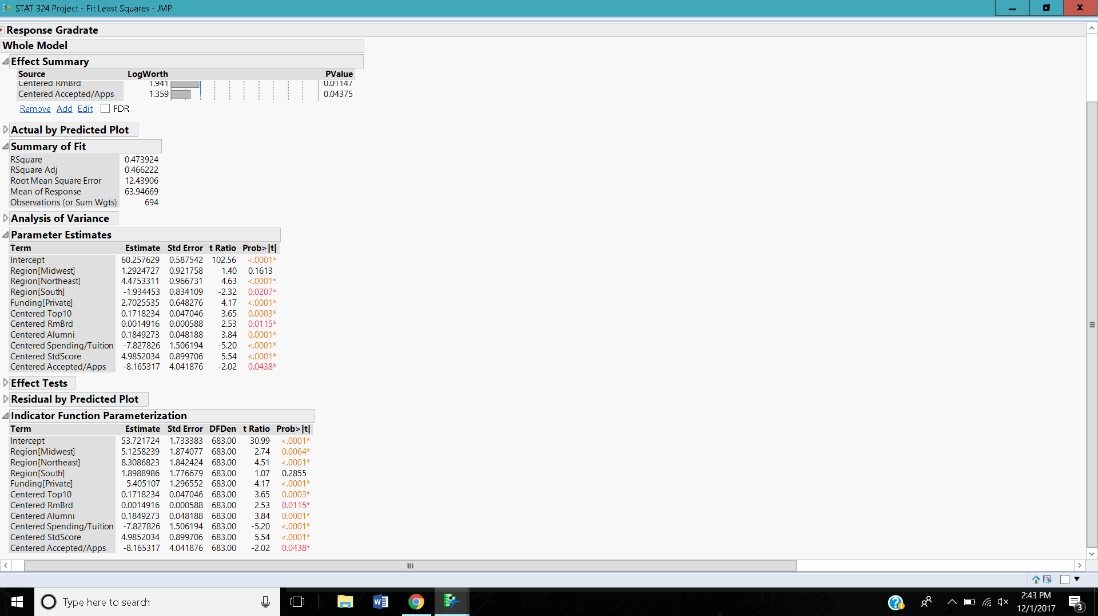 ←---------THIS IS IT